# **Request Engine - Low Level Design (LLD)**

Author:-

Harsh Nair- harshnair02@gmail.com

## **Purpose**

The Request Engine is a modular, asynchronous system built to send customized HTTPS requests through rotating proxies with TLS fingerprinting, classify the responses, log them in structured format, and expose Prometheus metrics for observability.

## **Core Modules Overview**

### **1. ConfigLoader**

* Loads YAML configuration
* Exposes dictionary of targets, proxies, TLS profiles

### **2. ProxyManager**

* Maintains internal list of proxies
* Provides round-robin rotation (rotate_proxy())

### **3. TLSFingerprintModule**

* Returns randomized browser-like headers
* Current spoofing level: User-Agent header only

### **4. HTTPSRequestEngine**

* Makes asynchronous HTTPS requests via httpx.AsyncClient
* Accepts custom headers, TLS profile, and proxy
* Gracefully handles request exceptions

### **5. ResponseClassifier**

* Detects status:  
  + SUCCESS (200)
  + BLOCKED (403, 429)
  + CAPTCHA (text match)
  + UNKNOWN (everything else)

### **6. StructuredLogger**

* Logs events in structured JSON using loguru
* Events: request_sent, response_received

### **7. MetricsCollector**

* Exposes Prometheus-compatible counters
* Metrics served via embedded HTTP server

### **8. RequestManager**

* Orchestrates the full lifecycle
* Applies ProxyManager, TLS module, Engine, Classifier, Logger, and Metrics

## **Class-Level Diagram**

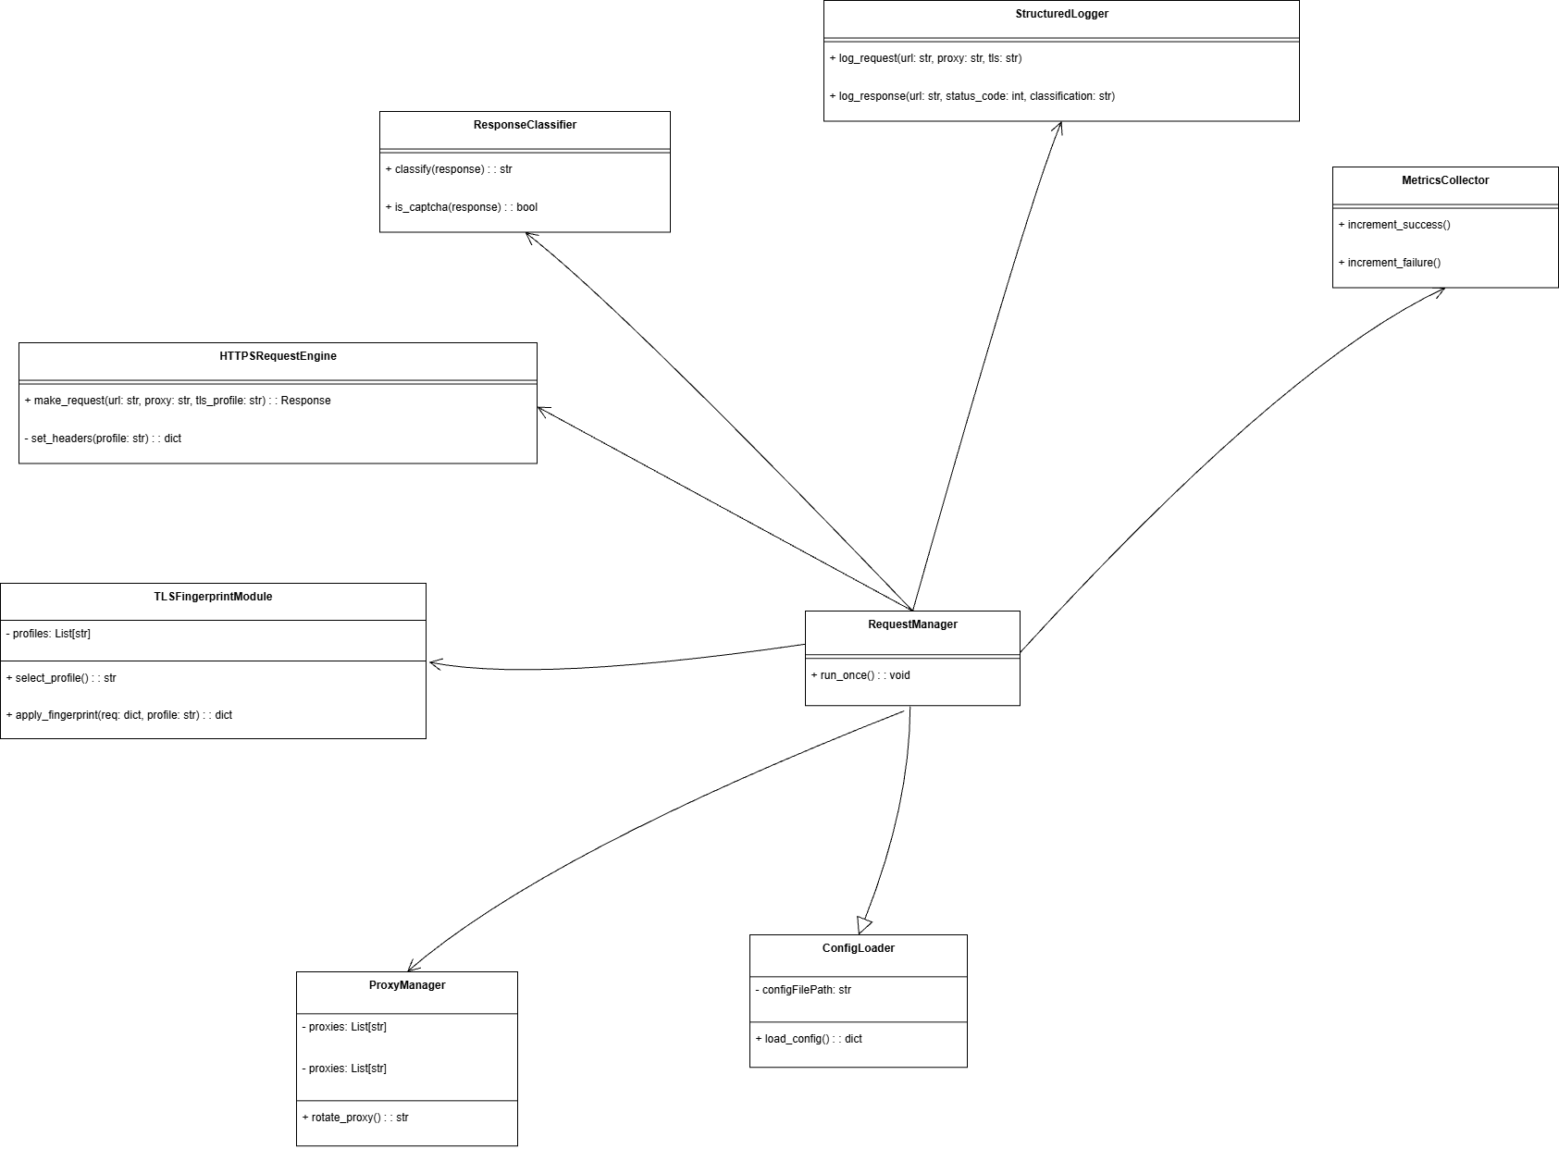

## **Request Execution Flow**

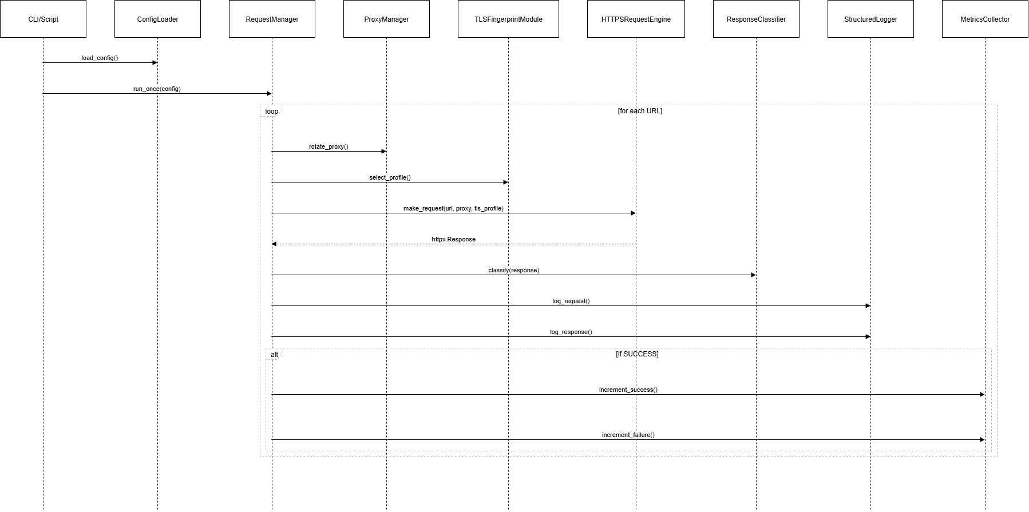

## **Error Handling Strategy**

| **Component** | **Error Type** | **Handling** |
| --- | --- | --- |
| ConfigLoader | FileNotFound, YAML error | Print + raise |
| HTTPSRequestEngine | Timeout, ConnectError | Print error, return None |
| ProxyManager | Empty list | Raise on init |
| TLSFingerprintModule | Empty list | Raise on init |
| RequestManager | Missing config keys | Use .get() with defaults |

## **Observability**

* /metrics: available on localhost:8000
* logs/logs.jsonl: structured logs
* Stdout prints key results for human readability

## **Extensibility Points**

| **Area** | **Extension** |
| --- | --- |
| Classification | Add logic in ResponseClassifier |
| Exporters | Extend StructuredLogger |
| Retry logic | Add backoff in RequestManager |
| Web GUI | Plug into main.py with Gradio or Streamlit |

## **Security Notes**

* No credentials are hardcoded
* Supports authenticated proxies via config
* TLS spoofing is header-only for now (safe fallback)

## **Maintainer Guidelines**

* Keep each class small and single-responsibility
* Avoid global variables or hardcoded values
* Validate all config at the start
* Use async def consistently

## **Deployment Notes**

* Can be containerized easily
* Self-contained Prometheus metrics (no external exporter needed)
* Easily integrate with CI/CD by calling main.py